# Using Factoring to Find Zeros of Polynomial Functions

We can solve polynomial functions by factoring and using the zero product rule (like for quadratics) OR by using a graphing calculator.

Given a polynomial function $f$, find the $x$-intercepts by factoring.

1)

2)

3)

Examples: Find the zeros of the given polynomial functions.

1) $h\left(x\right)=3x{\left(x-6\right)}^{2}{\left(x-16\right)}^{2}$

2) $g\left(x\right)=-x^{3}+4x$

3) $f\left(x\right)=x^{3}+11x^{2}+35x+32$

# Identifying Zeros and Their Multiplicities

Graphs behave differently at various $x-$ intercepts. Sometimes, the graph will cross over the horizontal axis at an intercept. Other times, the graph will touch the horizontal axis and “bounce” off.Graphically, this means that the graph will either cross the $x-$ axis OR touch the $x-$ axis and turn around.

If a polynomial contains a factor of the form ${\left(x-h\right)}^{p}$, the behavior near the $x-$ intercept $h$ is determined by the power of $p$. We say that $x=h$ is a zero of **multiplicity $p$** .

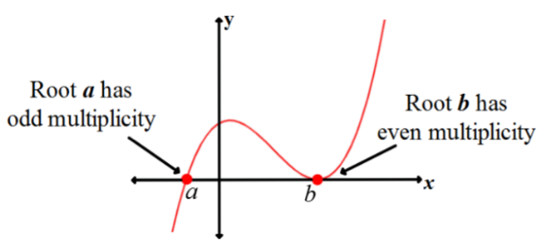

The graph of a polynomial function will touch the $x-$ axis at zeros with even multiplicities. The graph will cross the $x-$ axis at zeros with odd multiplicities.

Examples:

1. Given the function $f\left(x\right)={\left(x+5\right)}^{2}\left(x+7\right){\left(x-4\right)}^{2}$, find the zeros and multiplicities.
2. Given the graph below, find the zeros and multiplicities.

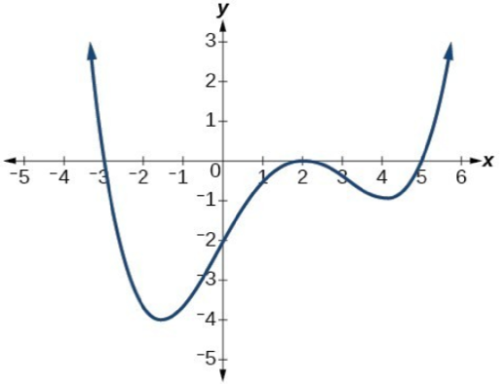

# Graphing Polynomial Functions

1)

2)

3)

4)

5)

6)

7)

Examples:

1. Graph the following polynomial and answer the following questions. $$f\left(x\right)=-x^{4}+x^{3}+2x^{2}$$

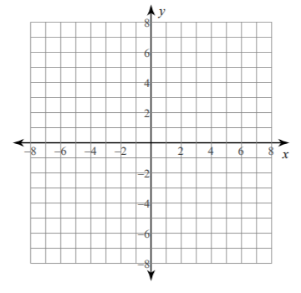

Degree:

Leading Coefficient:

Domain:

Range:

Intervals of Increase:

Intervals of Decrease:

Constant Interval:

$x$-intercept(s):

$y$-intercept(s):

Relative/Local Maximum:

Global Maximum:

Relative/Local Minimum:

Global Minimum:

End behavior:

As $x→∞, f(x)→$

As $x→-∞, f(x)→$

Zeros and Multiplicities:

1. Use technology to find the maximum and minimum values on the interval $[-1,4]$ of the function $f\left(x\right)=-0.2{\left(x-2\right)}^{3}{\left(x+1\right)}^{2}\left(x-4\right)$

# Writing Formulas for Polynomial Functions

Now that we know how to find zeros of polynomial functions, we can use them to write formulas based on graphs. Because a polynomial function written in factored form will have an $x-$ intercept where each factor is equal to zero, we can form a function that will pass through a set of $x-$ intercepts by introducing a corresponding set of factors.

If a polynomial of lowest degree $p$ has horizontal intercepts at $x=x_{1}, x_{2}, …, x_{n}$, then the polynomial can be written in the factored form:

$$f\left(x\right)=a{\left(x-x_{1}\right)}^{p_{1}}{\left(x-x_{2}\right)}^{p_{2}}…{\left(x-x_{n}\right)}^{p_{n}}$$

Where the powers $p_{i}$ on each factor can be determined by the behavior of the graph at the corresponding intercept, and the strtch factor $a$ can be determined given a value of the function other than the $x$-intercept.

So, given a graph of a polynomial function, we should be able to write an equation by looking at $x$-intercepts, multiplicities, and end behavior.

Given a graph of a polynomial, we can write the equation by

1)

2)

3)

4)

Examples: Write an equation for each of the polynomial functions graphed below.

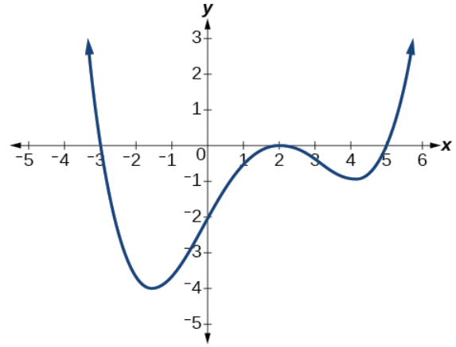

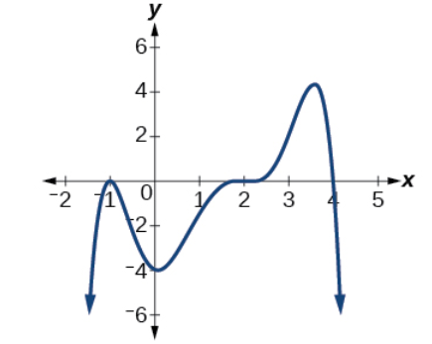

# Using the Intermediate Value Theorem

In some situations, we may know two points on the graph but not the zeros. If those two points are on opposite sides of the $x$-axis, we can confirm that there is a zero between them.

Let $f$ be a polynomial function. The **Intermediate Value Theorem** states that if $f(a)$ and $f(b)$ have opposite signs, then there exists at least one value of $c$ between $a$ and $b$ for which $f\left(c\right)=0$.

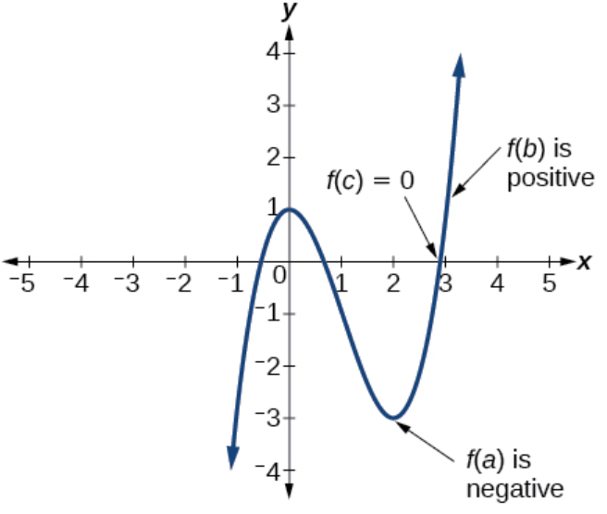

In other words, the Intermediate Value Theorem tells us that when a polynomial function changes from a negative value to a positive value, the function must cross the $x$-axis.

Example: Show that the function $f\left(x\right)=x^{3}-5x^{2}+3x+6$ has at least two real zeros between $x=1$ and $x=4$.